**Installing the Sensor**

**The First Step: Connecting the Wires**

*(refer to the back for pin numbers)*

First you will need three female to female cables, preferably all different colors. Two will be used to power and ground the sensor, the other one will be used for the digital output. You will also need the sensor and the Raspberry Pi.

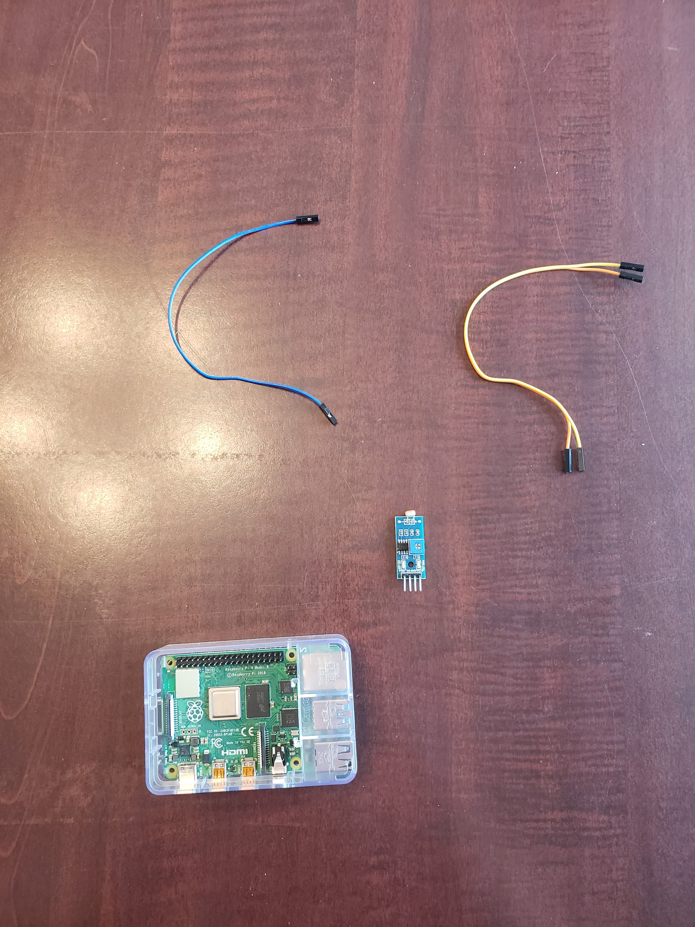

The blue cable will be used for the output while the orange and yellow for the ground and power. Once the materials are gathered, plug the blue cable or whatever colored cable you will use for the digital output into the sensor where it says DO, marked in red in the image below.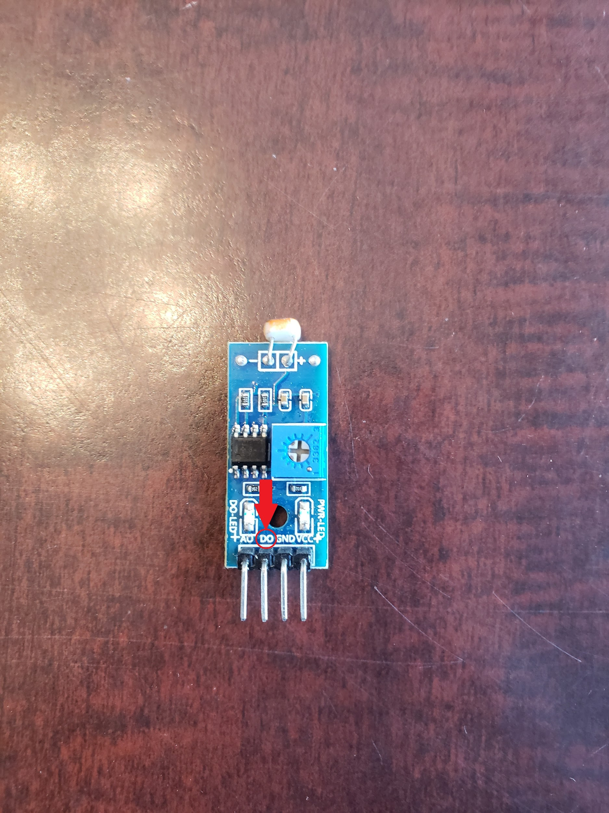

Once that is plugged in, connect the yellow cable to the pin to the right of DO marked GND, this will be your ground pin and after that connect the orange cable to the pin to the right of the GND pin marked VCC, this will be the power for the sensor as seen in the image below.

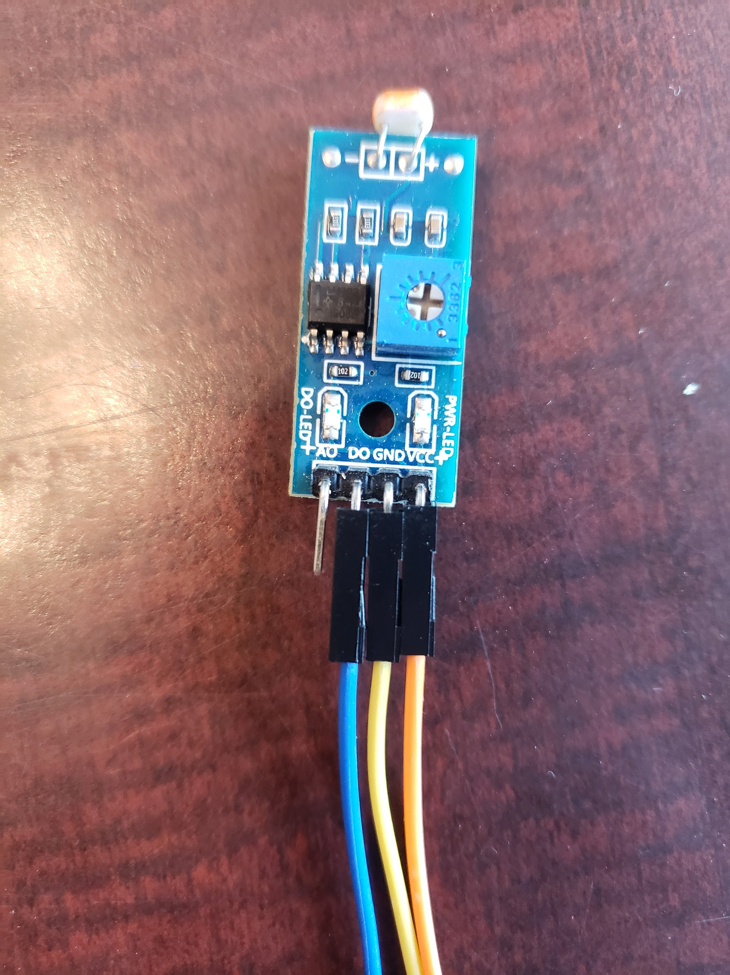

With these cables plugged into the sensor, it’s time to plug them into the main board of the Raspberry Pi. First start with the blue cable, plug it into pin 7, this is a general purpose input/output pin known as GPIO 4.

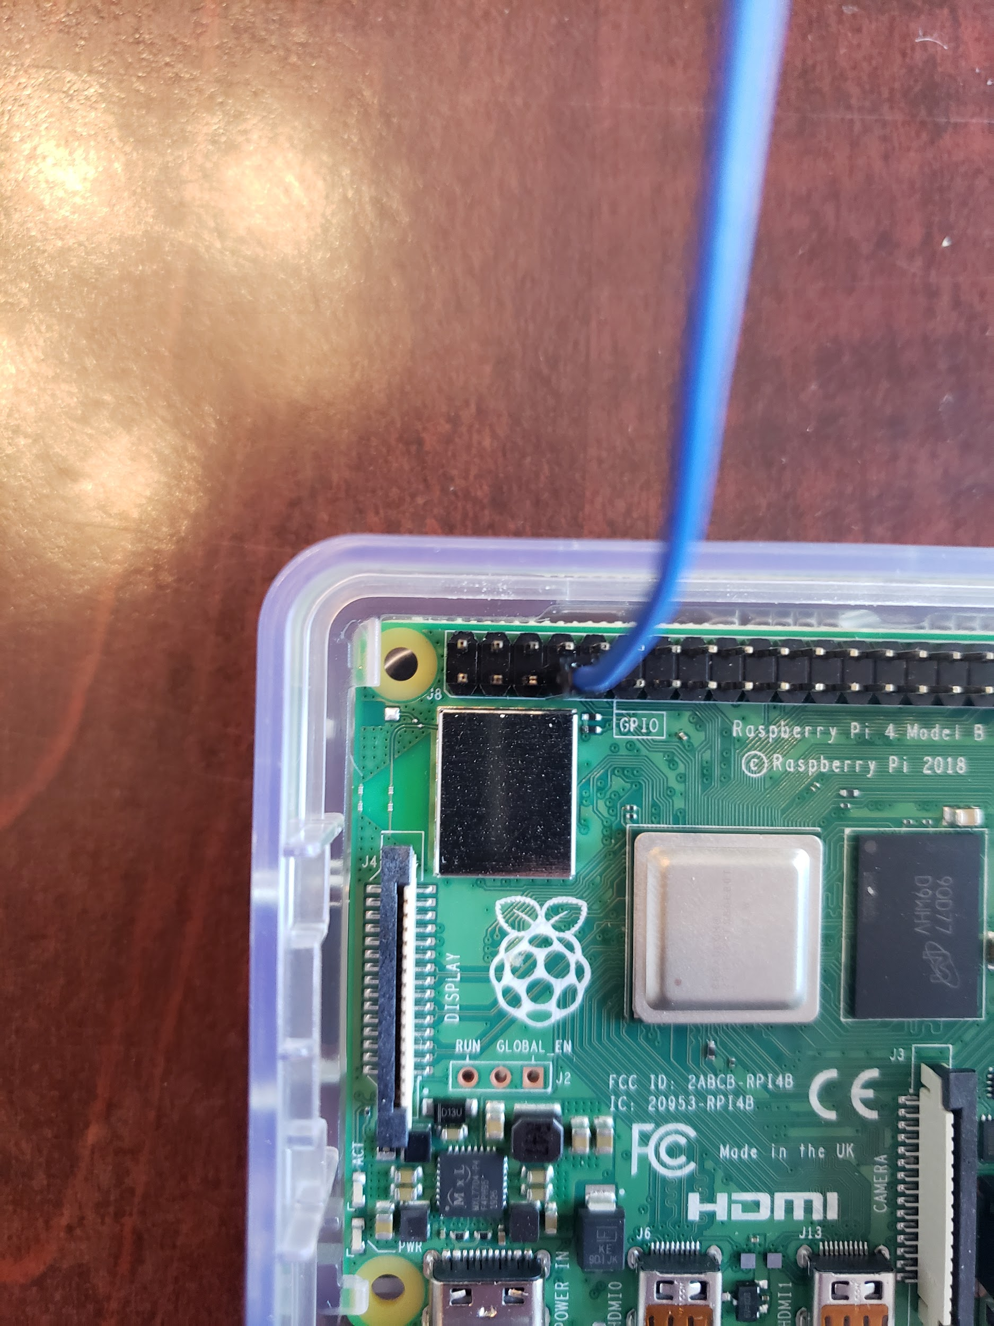

With that done, you can proceed to plug in the power cables, the orange cable will be plugged into pin 1, which is the 3.3V power supply pin. Then the yellow cable can be plugged into pin 6 which is a grounded pin.

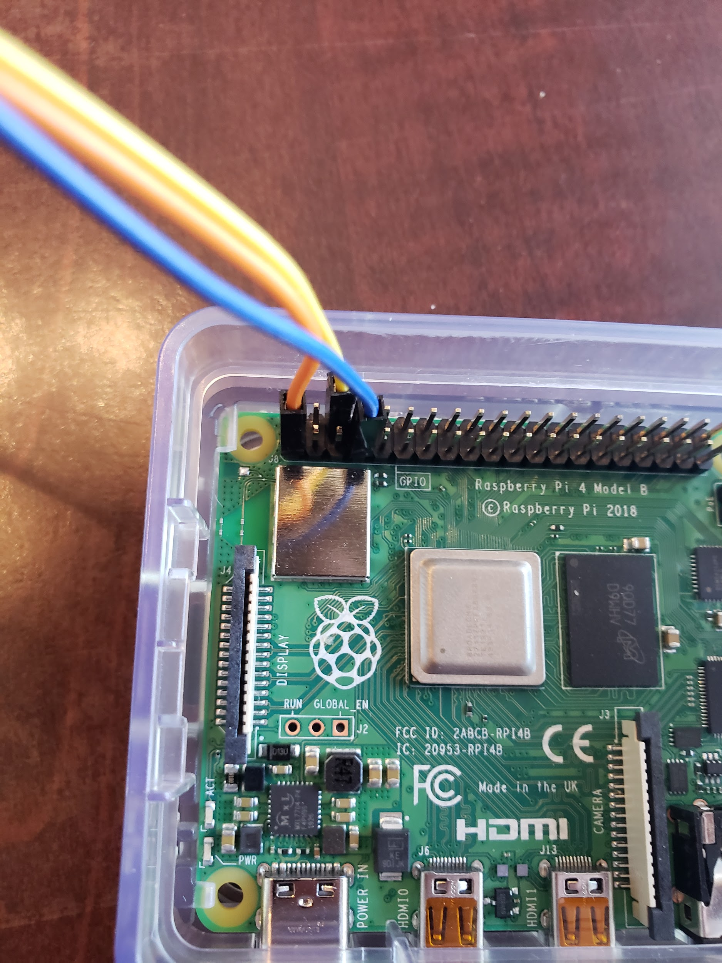

All done, the cables are all connected!

**Step Two: Programming the Sensor**

This simple code, basically creates two lists of times and the state of the sensor, then outputs it at will.

import RPi.GPIO as GPIO

from datetime import datetime

listTime = []

listData = []

GPIO.setmode(GPIO.BCM)

GPIO.setup(4, GPIO.IN)

#gets the current time and puts it in a list

def currTime():

now = datetime.now()

current_time = now.strftime("%H:%M:%S")

compileList(current_time)

#helper method that puts the actual time in the list

def compileList(currentTime):

listTime.append(currentTime)

#iterates through the two lists to print out the times and states

def showTimes():

for (x, y) in zip(listTime, listData):

print(x + " State: " + y)

#the main function that runs through and prompts the user if they want to save the data.

def runTime():

while True:

print("Would you like to save the data and time?")

answer = input()

if answer == "y":

if (GPIO.input(4) == 1):

listData.append("Dark")

else:

listData.append("Light")

currTime()

else:

break

print("Would you like a list of saved times and data?")

response = input()

if response == "y":

showTimes()

break

runTime()

**PINS**

